**SVKM’s NMIMS**

**Mukesh Patel School of Technology Management & Engineering**

**Department of Electronics and Telecommunication Engineering**

**Subject: Machine Learning Program: MBA.Tech**

**Sem: III/V ACAY: 2020-21**

**EXPERIMENT NO. 1**

**Aim:**

1. To write a programs in Python using if else statements, functions
2. To be able to use packages like Math, NumPy and Matplotlib to implement simple programs.

**Software:**  PYTHON.

**Prerequisite:**

|  |  |
| --- | --- |
| Sr. No | Concepts |
| 1. | Basic programming concepts |

**Outcome:**

After successful completion of this experiment students will be able to:

1. Understand the basics of python
2. Use different packages like Math, NumPy, Matplotlib in python.

**Theory:**

Python is a widely used programming language

• First implemented in 1989 by Guido van Rossum

• Free, open-source software with community-based development

• Trivia: Python is named after the BBC show “Monty Python’s Flying Circus” and has nothing to do with reptiles

**Math module**

This module provides access to the mathematical functions defined by the C standard.

These functions cannot be used with complex numbers; use the functions of the same name from the [cmath](https://docs.python.org/3/library/cmath.html" \l "module-cmath) module if you require support for complex numbers. The distinction between functions which support complex numbers and those which don’t is made since most users do not want to learn quite as much mathematics as required to understand complex numbers. Receiving an exception instead of a complex result allows earlier detection of the unexpected complex number used as a parameter, so that the programmer can determine how and why it was generated in the first place.

**Numpy**

* The fundamental package for scientific computing with *Python*.
* NumPy, which stands for Numerical Python, is a library consisting of multidimensional array objects and a collection of routines for processing those arrays.
* Using NumPy, mathematical and logical operations on arrays can be performed.

**Matplotlib**

* Matplotlib is a comprehensive library for creating static, animated, and interactive visualizations in Python.
* Matplotlib produces publication-quality figures in a variety of hardcopy formats and interactive environments across platforms.
* Matplotlib can be used in Python scripts, the Python and IPython shell, web application servers, and various graphical user interface toolkits.

**TO BE COMPLETED BY STUDENTS**

* Students must upload the soft copy of the program in the given format.

|  |
| --- |
| Name of the Experiment |
| Roll No.: N049 Name: Tarun Tanmay |
| Program MBA Tech CE Semester : 5 |
| Date of Performance: Date of Submission: |

1. **Program to find if the number is divisible by three.**

**Code:**

**num=int(input("Enter number"))**

**print("Divisible by 3") if (num%3==0) else print("Not divisible")**

**Output:**



1. **Program to find if the number is divisible by 3 by taking input from user.**

**Code:**

**num=int(input("Enter number"))**

**print("Divisible by 3") if (num%3==0) else print("Not divisible")**

**Output:**



1. **Program for calculator to perform basic operations of addition, subtraction, multiplication and division.**

**Code:**

**num1=int(input("Enter 1st number"))**

**num2=int(input("Enter 2ns number"))**

**print(num1,"+",num2,"=",num1+num2)**

**print(num1,"-",num2,"=",num1-num2)**

**print(num1,"/",num2,"=",num1/num2)**

**print(num1,"*",num2,"=",num1*num2)**

**Output:**

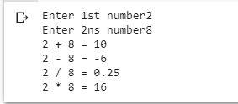

1. **Program to change case of a string**

**Code:**

**mystr=input("Enter String")**

**print(mystr.capitalize())**

**print(mystr.upper())**

**Output:**

1. **To print the last character in a string.**

**Code:**

**mystr=input("Enter String")**

**print(mystr[-1])**

**Output:**

1. **Program to display class based on marks**

**Code:**

**marks=input("Enter the marks")**

**def calc(marks):**

**if marks<"35":**

**return "Fail"**

**elif marks<"60" and marks>"34":**

**return "3rd class"**

**elif marks<"80" and marks>"59":**

**return "2nd class"**

**else:**

**return "1st class"**

**ans=calc(marks)**

**print(ans)**

**Output:**



1. **Find the slope of a line, given the coordinates of two points on the line.**

**Code:**

**p1=[float(x) for x in eval((input("Enter point 1")))]**

**p2=[float(x) for x in eval((input("Enter point 2")))]**

**slope=(p2[1]-p1[1])/(p2[0]-p1[0])**

**print(slope)**

**Output:**

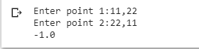

1. **Using the NumPy package, prepare an array called income for 6 employees. Let the expenses be 65% of the income. Print the savings of the employees as an array.**

**Code:**

**import numpy as np**

**arr = np.array([10000, 20000, 30000, 40000, 50000,60000])**

**ans=arr-(0.65*arr)**

**print(ans)**

**Output:**



1. **Plot a scatter plot of two random variables having normal distribution. Use numpy package.**

**Code:**

**import numpy as np**

**x=np.random.normal(0,1,100)**

**y=np.random.normal(0,1,100)**

**plt.plot(x,y)**

**Output:**

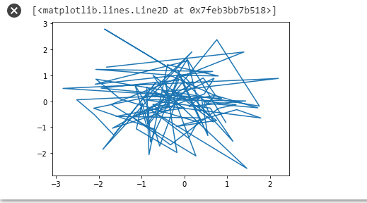

1. **Show a scatter plot of the following points of 5 points in two dimensional space**

**Code:**

**import matplotlib.pyplot as plt**

**import numpy as np**

**age=[10,20,30,40,50]**

**weight=[25,40,65,70,60]**

**plt.scatter(age, weight, marker='o');**

**Output:**

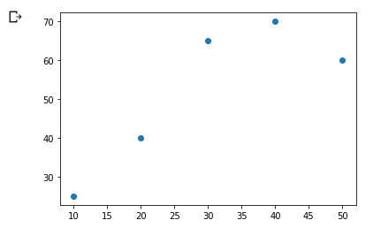

**Conclusion:**

All the codes were performed and understood by us.